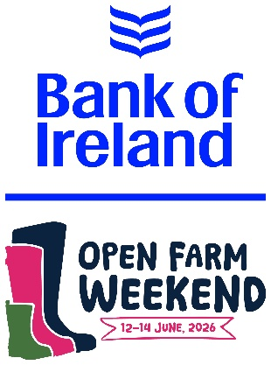
BANK OF IRELAND OPEN FARM WEEKEND SCHOOLS’ PROGRAMME:

SCHOOLS’ BOOKING FORM 2026

Farm visit name: _______________________________________________
Date of visit: Friday 12 June 2026.

School information
School name: _________________________________________________

School address including postcode:
_____________________________________________________________

_____________________________________________________________

_____________________________________________________________

School teacher/leader contact information

Contact person/leader of the pupils:
___________________________________________________________

Contact telephone number: ___________________________________
Contact email address: _______________________________________
Number of pupils attending the farm visit: _______________________
Number of adults accompanying the pupils: _____________________
Age range of pupils: __________________
Pupil/s medical condition/s which the farm host may need to be aware of:
___________________________________________________________________
___________________________________________________________________

Photographic permission
During the visit local press, farm hosts and Bank of Ireland Open Farm Weekend (BOIOFW) representatives may wish to take photographs of pupils to use on social media, the BOIOFW website and send to the local press.

By ticking this box, you consent to photographs being taken during the visit and to be published (press, social media and evaluation).

Allergies
Farms may provide refreshments during the visit. If pupils have any special requirements, please list them here:
_________________________________________________________________________
__________________________________________________________________________________________________________________________________________________

Activities
Some farms may arrange special activities. We will inform you of these and seek any relevant permissions in advance.

Next steps
Thank you for registering your schools’ interest the Bank of Ireland Open Farm Weekend schools’ day on Friday 12 June 2026. We will process your form and come back to confirm all details as soon as we can.

Please be aware that whilst we endeavour to host all schools that express interest, we are limited by the location of participating farms and visits are granted on a first come, first served basis.
Please complete and return this form to rmcclenaghan@ufuhq.com.

If you require any assistance, please contact:
Rebecca McClenaghan
BOIOFW schools’ coordinator and UFU communications officer
- Email: rmcclenaghan@ufuhq.com
- Contact: 02890 370222 / 07917457141

FARM HOST INFORMATION

(To be completed by BOIOFW)

Date form received _ _ / _ _ / _ _ _ _

Farm confirmed for visit:

_____________________________________________________

Farm address:
_____________________________________________________

_____________________________________________________

Contact person on the farm:

_____________________________________________________

Contact telephone number:
_____________________________________________________

Time of visit on Friday 12 June 2026: _____________________

Notes/special information from school:
_________________________________________________________________________

_________________________________________________________________________

_________________________________________________________________________

Date copy sent to the farmer: _ _ / _ _ / _ _ _ _

Date copy sent to the school: _ _ / _ _ / _ _ _ _

