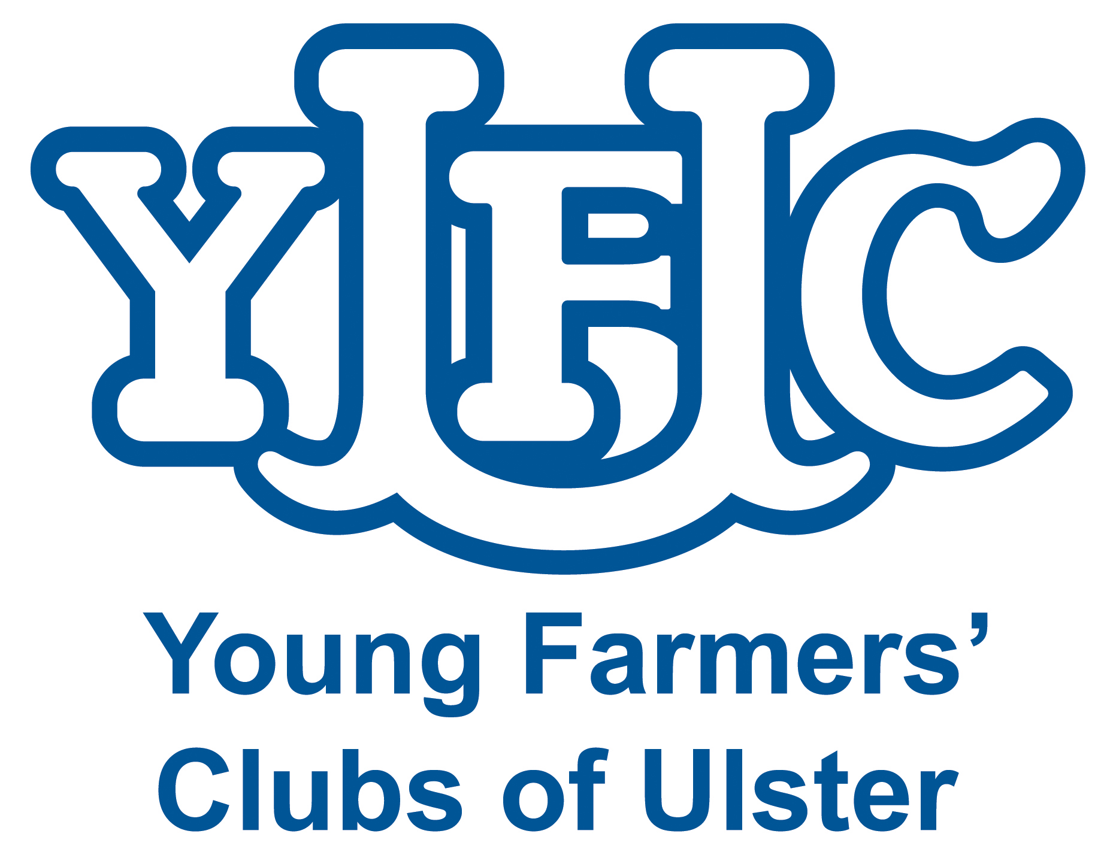

**Next Generation Development Forum**

**Application Form**

**Name:**

**Address:**

**Telephone:**

**Mobile:**

**E: mail:**

**UFU Membership Number:**

**Main Areas of Interest:**

**Describe nature of farm business involvement:**

**What issues do you feel should be discussed by the Group?**

**In no more than 300 words please highlight what you can contribute to the Next Generation Discussion Forum? (e.g. relevant experience, representation, interests etc.)**

Completed forms should be returned to James McCluggage, Ulster Farmers’ Union, 475 Antrim Road, Belfast , BT15 3DA

Or e-mail: [jmccluggage@ufuhq.com](mailto:jmccluggage@ufuhq.com)